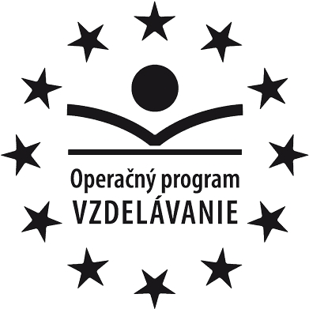


Moderné vzdelávanie pre vzdelávanie pre vedomostnú spoločnosť / Projekt je spolufinancovaný EÚ
Výstup aktivity

Názov aktivity: 2.1 Inovácia výchovno-vzdelávacieho procesu v oblasti jazykového vzdelávania
Názov činnosti: Tvorba výstupu pre predmet Anglický jazyk,
oblasť 2/Aktívne používanie cudzieho jazyka v praxi:
Pracovný list s názvom Opakovanie 6. lekcie

Meno a funkcia v projekte: Mgr. Lucia Lengyelová, 4.1.1. Metodik anglického jazyka 1
Termín spracovania: 19.2.2014
Opakovanie 6. lekcie

1. Role-play  Work in pairs.  Person 1: You weren’t at school, because you were ill.  Person 2: You were at school and you went to a trip to Aquacity Poprad.  Speak about your experiences.  Use phrases from exercise 4a/75, if possible. | 2. Picture story  Make up a story about the picture below.  Tell the class.  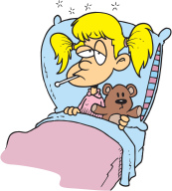
3.Reading comprehension  Read the text and answer the questions.  An accident happened during the World Clipper Race, where competitors currently race to San Francisco from China.  A competitor was changing a sail when he fell over the side of his boat. The high winds swept him away from the ship. He fell into the ice-cold water. People on the ship looked for him. It took them about one and a half hour long.  The man was in shock and his body temperature was very low.  Question: What happened to the competitor?  How long did it take people to find him?  Source: http://www.newsinlevels.com/products/man-saved-from-cold-water-level-2/ | 4.Grammar  Write as many sentences as you can using must, mustn’t, don’t have to, should, shouldn’t  .......................................................................  .......................................................................  .......................................................................  .......................................................................  .......................................................................  .......................................................................  .......................................................................  .......................................................................  .......................................................................  .......................................................................  .......................................................................  .......................................................................  .......................................................................  .......................................................................  .......................................................................  .......................................................................  .......................................................................

